1. 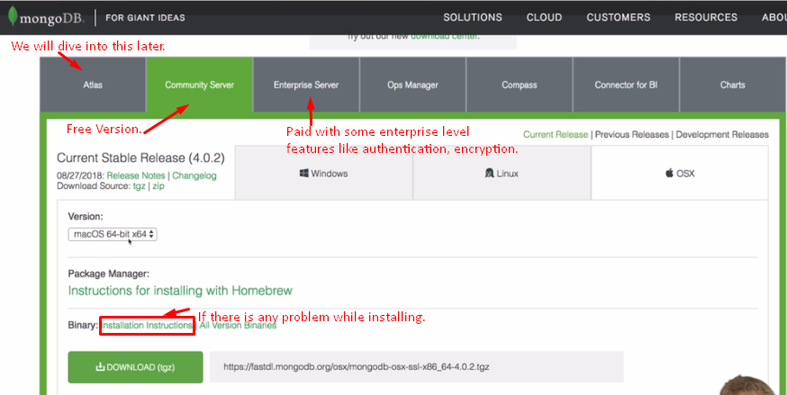
2. 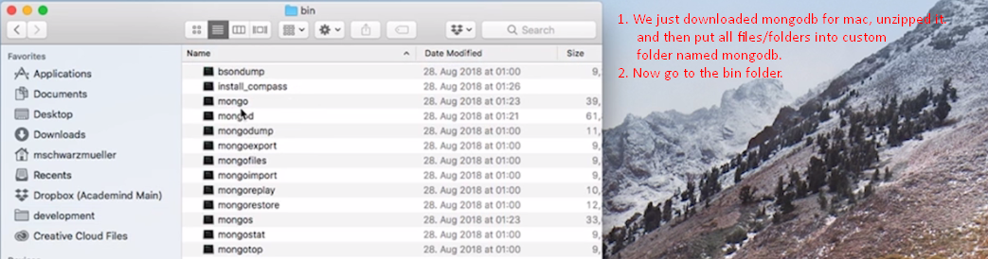
3. 
4. NOTE: In windows, we will get the same executables in bin folder.  
   In bin folder, you will find a lot of executables which you will use for the following purposes.
   1. One to start our mongodb server which will host mongodb databases.
   2. One to import data.
   3. Shell client to connect with mongodb databases and allows us to run commands on the databases.